CO1 EXPERIMENT 04

Aim
To simulate and compare the Bit Error Rate (BER) of Zigbee, 6LoWPAN, and NB-IoT technologies at different communication distances.

Short Procedure
- Import NumPy, Matplotlib, and SciPy libraries.
- Define the communication distance from 10 m to 1000 m.
- Set the transmission power, path loss, path loss exponent, and noise power for each technology.
- Calculate path loss, received power, and Signal-to-Noise Ratio (SNR).
- Calculate BER using the complementary error function (erfc).
- Plot BER against distance using a logarithmic scale for each technology.

PROGRAMINNG CODE

Import numpy as np
import matplotlib.pyplot as plt
from scipy.special import erfc

distance = np.linspace(10, 1000, 100)

# =====================================================
# Common BER equation
# BER = 0.5 * erfc(sqrt(SNR))
# =====================================================

# =====================================================
# 1. ZIGBEE
# =====================================================

Pt = 0 # Transmit power (dBm)
PL0 = 40 # Path loss at 1 m (dB)
n = 3.0 # Path loss exponent
N = -107 # Noise power (dBm)

PL = PL0 + 10*n*np.log10(distance)
Pr = Pt - PL
SNR = Pr - N

BER = 0.5 * erfc(np.sqrt(10**(SNR/10)))
print(BER[0])

plt.figure(figsize=(7,5))
plt.semilogy(distance, BER)
plt.xlabel("Distance (m)")
plt.ylabel("Bit Error Rate (BER)")
plt.title("Zigbee: BER vs Distance")
plt.grid(True)
plt.show()

# =====================================================
# 2. 6LoWPAN
# =====================================================

Pt = 0
PL0 = 40
n = 3.0
N = -107

PL = PL0 + 10*n*np.log10(distance)
Pr = Pt - PL
SNR = Pr - N

BER = 0.5 * erfc(np.sqrt(10**(SNR/10)))
print(BER[1])

plt.figure(figsize=(7,5))
plt.semilogy(distance, BER)
plt.xlabel("Distance (m)")
plt.ylabel("Bit Error Rate (BER)")
plt.title("6LoWPAN: BER vs Distance")
plt.grid(True)
plt.show()

# =====================================================
# 3. NB-IoT
# =====================================================

Pt = 23
PL0 = 31
n = 3.5
N = -107

PL = PL0 + 10*n*np.log10(distance)
Pr = Pt - PL
SNR = Pr - N

BER = 0.5 * erfc(np.sqrt(10**(SNR/10)))
print(BER[2])

plt.figure(figsize=(7,5))
plt.semilogy(distance, BER)
plt.xlabel("Distance (m)")
plt.ylabel("Bit Error Rate (BER)")
plt.title("NB-IoT: BER vs Distance")
plt.grid(True)
plt.show()

N(dbm) | Zigbee(10) | 6LoWPAN(20) | NB-IoT(400)
100 | 0.0 | 1.298 | 0.0
85 | 9.125 | 0.0024 | 1.0021
107 | 0.0 | 9.397 | 0.0

OUTPUT

Z=100

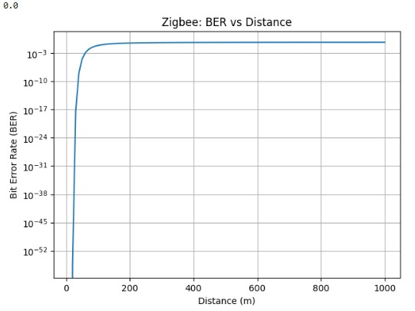

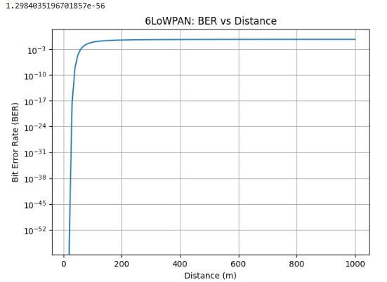

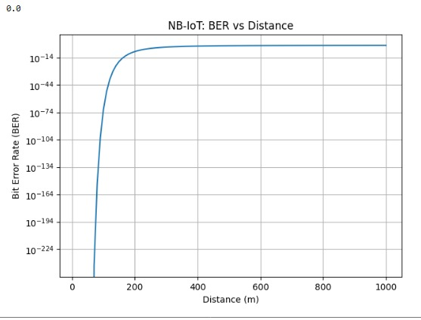

Z=85
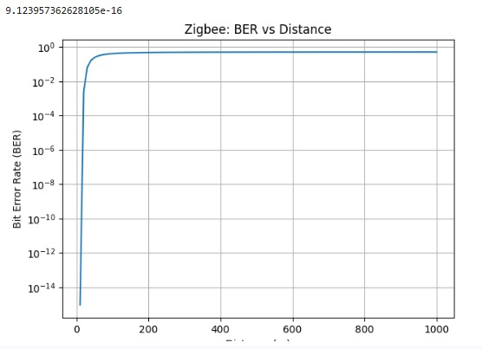

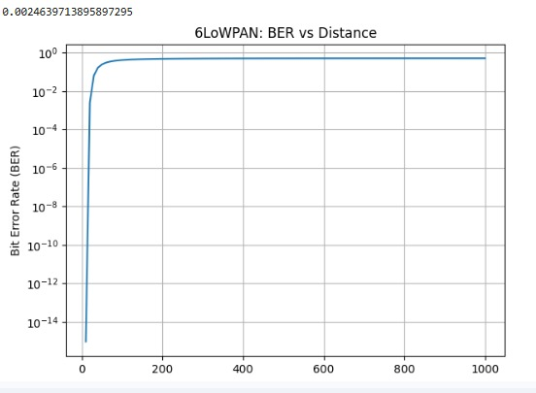

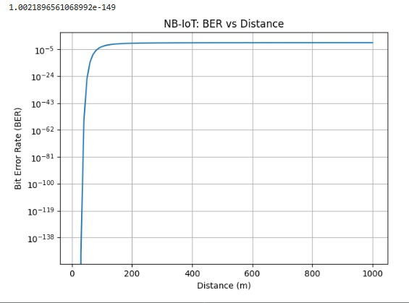

Z=107

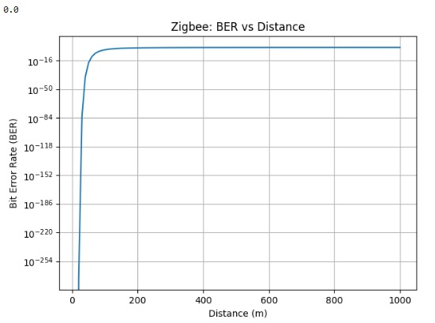

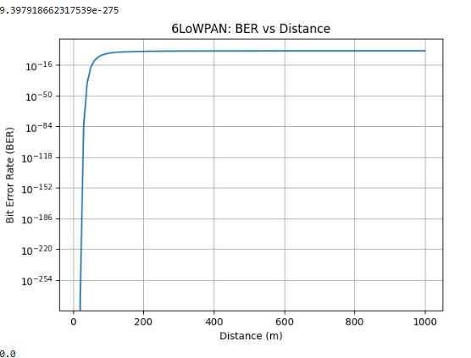

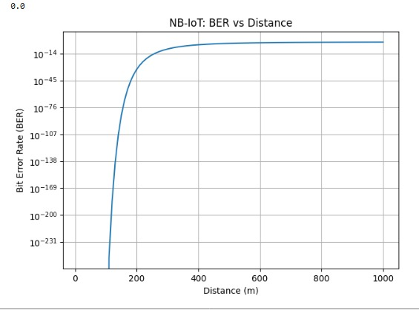

Result
The BER of Zigbee, 6LoWPAN, and NB-IoT was simulated and plotted successfully. The graphs illustrate how communication distance affects signal quality and bit error rate. Generally, as distance increases, SNR decreases and BER increases. NB-IoT uses different assumed transmission parameters, so its performance may differ from Zigbee and 6LoWPAN

